# CS 340 README Template

## About the Project/Project Title

This project creates an interactive dashboard for Grazioso Salvare that enables users to filter and view the shelter’s database and view available dogs that are ideal for different types of rescue services. To make the dashboard more user friendly, a pie chart and interactive map are included in the display.

## Motivation

Starting with only the shelter’s database, MongoDB was utilized for easy exploration. Using Python, a script was created to manipulate the data. The CRUD module written in Jupyter notebook allowed users to create new data entries, search for entries, and update or delete existing entries within the database. In order to better utilize the information within the database however, an interactive dashboard was needed to filter through the entries.

## Getting Started

To replicate this project, you will first need to gain access to the Mongo shell and upload the necessary database via MongoDB. A user account will need to be created with read/write privileges. For this project, that user is “aacuser”. The next step involves creating a CRUD module in Python, as stated above, Jupyter Notebook was used for all of the Python coding in this project. The final step involves utilizing Dash and importing Dash file to the notebook to successfully launch the dashboard.

## Installation

You will need to ensure that you have several programs either installed or correctly imported in order to recreate this program.

* MongoDB
  + For the database
* Jupyter Notebook
  + IDE utilized for creating Python code
* Python
  + Python 3 was used in this instance
* Dash
  + Necessary for creating the interactive dashboard
* Pandas
  + Python tool that allows for creation of data frames
* Plotly
  + Necessary in creating the graphs

## Usage

The Python program has four main functions. The first function, create, allows for creation of new entries into the database. The read method has both a readAll function and a search function, which will allow the user to either view all entries in the database, or search for a specific entry. The third function allows for updates to existing entries within the database, and then the delete function removes entries from the database.

Methods from Python CRUD Module:

This dashboard has three main features. The first is the datatable, which includes radial buttons that filter results the match the desired sex, age, and breed for certain types of rescue. Selection of any of the three options will filter through the database and display all matching results for that type of rescue. The final option is a reset button, which will clear all filters and display all entries in the database. The next feature is the pie chart, located under the datatable. This pie chart analyzes the breeds available for each filter and displays the proportion of each breed in a color-coded fashion. The last feature in the dashboard is the interactive map, the map defaults to the first row in the data table, but updates automatically when a new entry in the table is selected.

**Showing results with the Water Rescue Filter:**

**Showing Results with Disaster Rescue Filter:**

**Showing Results with the Mountain / Wilderness Filter:**

**Reset Button Clears All Filters:**

### Code Example

Before anything else can be done, the file needs to be uploaded into MongoDB. A user account can then be created with read/write permissions in order to manipulate the database via the Python script.

Uploading the file

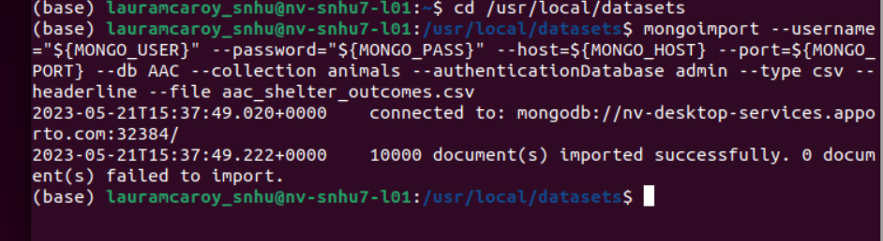

Creating a user account and gaining access to the database

With access to the database granted with permissions to read and modify, we created a Python script to create and read entries within the database. Screenshots of the Python methods are included above.

This code imports all of the necessary libraries and files needed to run the dashboard, as well as include the Python CRUD module (animal_shelter.py).

These segments of code involve creating and personalizing the data table, as well as creating the parameters for the filters.

Code that creates the Pie Graph:

Code that creates and updates the map:

### Tests

A test file was created to test the functionality of the python code.

This test file defines the data to be created, then attempts to create a new item in the database with that data and return the new entry as a search result. Further testing was done on the update and delete methods but was unsuccessful, as shown in below screenshots. Further testing on this program is needed but is not priority at this time.

### Screenshots of Testing

Testing results of Create and Read Methods

Unresolved testing errors involving update method

Unresolved testing errors involving delete method

## Contact

Your name: Laura McAroy